1. Three Real-Life Scenarios Where a Multimeter Is Used
A multimeter is an electronic testing device used to measure voltage, current, and resistance. It helps technicians identify electrical problems in computers and smartphones.
No. | Real-Life Scenario | How the Multimeter Helps
1. | Computer power supply problem | It checks the output voltage of the SMPS to identify whether the power supply is working correctly.
2. | Laptop not charging | It checks the voltage of the laptop charger and charging port to identify power supply problems.
3. | Smartphone not turning on | It checks the battery voltage to determine whether the battery is damaged or discharged.

2. POST Card Motherboard Test
- What is a POST Card?
A POST (Power-On Self-Test) card is a hardware diagnostic tool used to identify problems during computer startup. It displays error codes that help technicians find faulty hardware components.
- A POST card is connected to the motherboard through a supported diagnostic slot.
- When the computer starts, the card displays hexadecimal POST codes.
- These codes indicate the stage of the startup process and help identify hardware problems.
- If the computer fails to start, the error code helps technicians identify possible problems with RAM, CPU, graphics, or other hardware components.

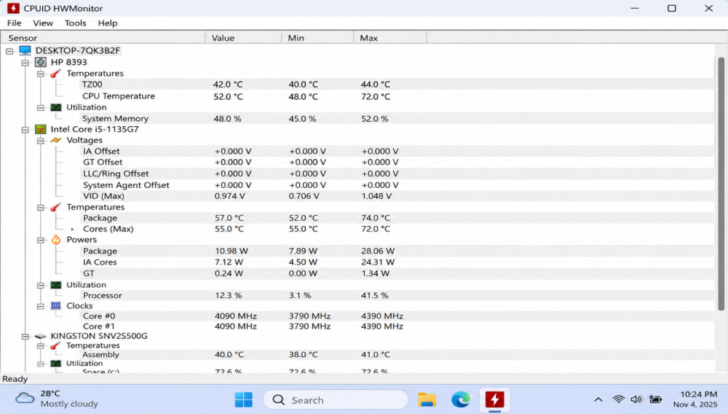
- Download and run a free diagnostic tool:

Practical Observation: HWMonitor displays CPU temperature, voltage, power consumption, processor utilization, and SSD temperature. The observed CPU temperature of 52°C and SSD temperature of 40°C indicate moderate operating temperatures. Unusually high temperatures may indicate cooling problems, while voltage readings help identify possible power-related issues.

4. Comparison of Multimeter, POST Card and Software Diagnostics
Tool | What it checks | Example Problem Detected
Multimeter | Voltage, current and resistance in electrical components. | Faulty laptop charger or low battery voltage.
POST Card | Motherboard startup process and hardware error codes. | RAM or CPU-related startup failure.
Software Diagnostics (HWMonitor) | CPU temperature, voltage, fan speed and hardware health information. | CPU overheating or abnormal voltage readings.

